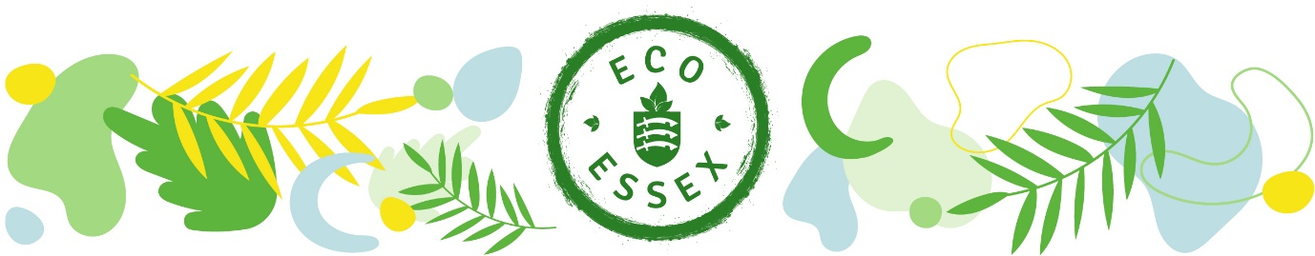
Eco books for adults

Alphabetical order by name of book

50 ways to help the planet by Sian Berry
101 ways to go zero by Kathryn Kellog

A
A beginners guide to eco-friendly living by Peace with the Wild (Free eBook)
An inconvenient truth by Al Gore

B
-

C
Chesapeake Requiem: A year with the watermen of vanishing Tangier Island by Earl Swift

D
-

E
Eaarth: Making a life on a tough new planet by Bill McKibben
Eco Thrifty Living Book by Zoe Morrison

F
Flight behaviour by Barbara Kingsolver

G
Green Clean – Eco friendly cleaning for the home
Green Swans: The Coming Boom in Regenerative Capitalism by John Elkington

H
-

I
-

J
Junk for joy! by Sian Berry

K
-

L
-

M
-

N
No One Is Too Small To Make A Difference by Greta Thunberg

O
Our House is on Fire: Scenes of a Family and a Planet in Crisis by Malena Ernman, Greta Thunberg, Beata Ernman and Svante Thunberg

P
-

Q
-

R
-
S
Sapiens: A Brief History of Humankind by Yuval Noah Harari
Saving The Planet Without Costing The Earth by Donnachadh McCarthy
Six degrees: Ourfuture on a hotter planet by Mark Lynas

T
The Future We Choose by Christiana Figueres and Tom Rivett-Carnac
The Happy Hero by Solitaire Solitaire Townsend
The hidden life of trees by Peter Wohlleben
The sixth extinction: An unnatural history by Elizabeth Kolbert
The Sustainiable(ish) Living Guide by Jen Gale
The Uninhabitable Earth: A Story of the Future by David Wallace-Wells and Active Hope by Joanna Macy
The Winning of the Carbon War by Jeremy Leggett
This changes everything: Capitalism vs the Climate by Naomi Klein
This Is Not A Drill: An Extinction Rebellion Handbook

U
-

V
-

W
We are the Weather: Saving the Planet Begins at Breakfast by Jonathan Safran Foer
Wildwood: A Journey Through Trees by Roger Deakin

X
-

Y
-
Z
-

